## A Project Report

**on**

**RICE MILL WEBSITE**

**submitted in partial fulfillment of the requirements for the award of the degree of**

**BACHELOR OF TECHNOLOGY**

**in**

**COMPUTER SCIENCE AND ENGINEERING**

**by**

**22WH1A0528 Ms. S. AKSHAYA**

**22WH1A0545 Ms. CH. BHUVANA**

**22WH1A0548 Ms. B. CHARITHA**

**22WH1A0562 Ms. P. TEJASWI**

**under the esteemed guidance of**

**Dr. Surya Narayana Reddy**

**Associate Professor**



**Department of Computer Science and Engineering**

BVRIT HYDERABAD

College of Engineering for Women

(NBA Accredited – EEE, ECE, CSE and IT)

**(Approved by AICTE, New Delhi and Affiliated to JNTUH, Hyderabad)**

**Bachupally, Hyderabad – 500090**

**July, 2024**

**DECLARATION**

We hereby declare that the work presented in this project entitled **“Rice mill website**”submitted towards completion of Project Work in II year of B. Tech, CSE at ‘BVRIT HYDERABAD College of Engineering For Women**’**, Hyderabad is an authentic record of our original work carried out under the guidance of Mr. Surya Narayana Reddy, Associate Professor, Department of CSE.

Sign. with date:

**Ms. S. AKSHAYA**

**(22WH1A0528)**

Sign. with date:

**Ms. CH. BHUVANA**

**(22WH1A0545)**

Sign. with date:

**Ms. B. CHARITHA**

**(22WH1A0548)**

Sign. with date:

**Ms. P. TEJASWI**

**(22WH1A0562)**

BVRIT HYDERABAD

College of Engineering for Women

(NBA Accredited – EEE, ECE, CSE and IT)

**(Approved by AICTE, New Delhi and Affiliated to JNTUH, Hyderabad)**

**Bachupally, Hyderabad – 500090**

**Department of Computer Science and Engineering**



###### Certificate

This is to certify that the Project Work report on “**RICE MILL WEBSITE**” is a bonafide work carried out by Ms. S. AKSHAYA (22WH1A0528); Ms. CH. BHUVANA (22WH1A0545) ; B. CHARITHA (22WH1A0548)**;** Ms. P. TEJASWI (22WH1A0562) in the partial fulfillment for the award of B.Tech. degree in **Computer Science and Engineering, BVRIT HYDERABAD College of Engineering for Women, Bachupally, Hyderabad**, affiliated to Jawaharlal Nehru Technological University Hyderabad, Hyderabad under my guidance and supervision.

The results embodied in the project work have not been submitted to any other University or Institute for the award of any degree or diploma.

**Head of the Department Guide**

**Dr. M Sree Vani, Dr.Surya Narayana Reddy**

**Professor, Associate Professor**

**Department of CSE Department of CSE**

**Contents**

|  |  |  |
| --- | --- | --- |
| **S.No.** | **Topic** | **Page No.** |
|  | Abstract | i |
|  | List of Figures | ii |
| 1. | Introduction | 1 |
| 2. | Literature Survey | 2 |
| 3. | Design | 3-5 |
| 4. | Implementation | 6-7 |
| 5. | Conclusion and Future Scope | 8 |
| 6. | References | 9 |

**ABSTRACT**

Our project aimed to develop a rice mill website, with a primary focus on creating a seamless and secure platform tailored for the rice milling industry. Key features included user authentication, streamlined payment processing, transaction tracking, and robust security measures. Development adhered to agile methodologies, with deployment on scalable cloud infrastructure. The project successfully emulated core functionalities akin to leading payment systems, ensuring potential for future enhancements. This initiative concentrated on crafting an intuitive user interface for entering bill details, securing payments through PIN verification, and logging transactions into a MySQL database. Key technologies utilized encompassed HTML, CSS, and JavaScript for frontend development, while Node.js and Express.js powered the backend, supported by MySQL for efficient database management. This report details the implementation process, challenges encountered, and outlines future enhancements, offering a comprehensive overview of the project's scope and functionalities tailored to the rice mill industry.

i

**List of Figures**

|  |  |  |  |
| --- | --- | --- | --- |
| S. No. | Fig No. | Fig. Name | Page. No |
| 1 | Figure1 | User Interaction Flow | 5 |
| 2 | Figure2 | Customers collection schema | 6 |
| 3 | Figure3 | Registered users login credentials | 6 |
| 4 | Figure4 | Products collection schema | 6 |
| 5 | Figure5 | Home page | 7 |
| 6 | Figure6 | Products Page | 7 |

ii

1. **INTRODUCTION**

Our project focuses on the development of a comprehensive web platform tailored for the rice milling industry. This endeavour leverages full-stack technologies to create a robust, user-friendly website that addresses the specific needs and challenges faced by rice mill operators and stakeholders.

The rice milling process, integral to agricultural economies worldwide, involves intricate operations from harvesting to processing and distribution. Historically, these processes have been managed through traditional means, often constrained by geographical limitations and inefficient communication channels. The advent of digital solutions presents an opportunity to streamline operations, enhance efficiency, and broaden market reach.

* 1. **Objectives**

Through this project we aimed to showcase our skills in software development, user interface design, integration and connectivity, providing insights for rice mill solutions:

• **Digital Transformation:** Facilitate the transition from traditional, paper-based processes to a digital platform for managing all aspects of rice milling operations.

• **Enhanced Efficiency:** Improve operational efficiency through automation of inventory management, order processing, and logistics, thereby reducing manual errors and optimizing resource utilization.

• **Improved Accessibility:** Provide a user-friendly interface accessible via web browsers, ensuring easy access to information and functionalities for stakeholders including mill operators, suppliers, and customers.

**1.2 Methodology**

Our methodology involved rigorous requirements gathering from stakeholders, followed by meticulous technology selection and system design as follows:

* Analyzed existing workflows and processes within the rice milling industry to determine key functionalities required for the web application.
* Evaluated various full-stack technologies and frameworks suitable for developing a robust and scalable web application.
* Selected technologies based on criteria such as ease of development, scalability, security features, and compatibility with industry standards.
* Created system architecture and design specifications based on the gathered requirements and selected technologies.
* Implemented front-end functionalities using HTML, CSS, JavaScript, and a chosen front-end framework (e.g., React, Angular) to create responsive and interactive user interfaces.Top of Form

1

Bottom of Form

**2. LITERATURE SURVEY**

The literature survey for this project involved a comprehensive review of academic and industry publications focused on digital solutions for rice mill operations. It aimed to identify existing technologies, methodologies, and challenges in optimizing efficiency and productivity within the rice milling industry.

The evolution of rice mill websites has been driven by a convergence of technological advancements and industry demands. Factors such as technological attitudes, cost-effectiveness, mobility, value propositions, and innovation play pivotal roles in shaping user behavior and industry practices. For instance, the integration of IoT devices for real-time monitoring of grain quality and moisture levels has revolutionized quality control practices in rice milling.[1]

Applications designed for rice mill operations have transformed how stakeholders interact with and manage mill activities. These applications offer mill managers, operators, and suppliers instant access to critical information on their mobile devices. For example, managers can monitor milling processes, track inventory levels, and oversee logistics in real-time, ensuring smooth operations and timely deliveries.[2]

The adoption of full-stack technologies in rice milling operations has revolutionized data management and scalability within the industry. By integrating comprehensive front-end and back-end solutions, rice mills can enhance operational efficiency and user experience. Full-stack development enables seamless integration of functionalities such as inventory management, quality control, and customer relationship management into a unified web application. This approach not only streamlines internal processes but also facilitates real-time data access and analytics, empowering decision-makers with actionable insights.[3]

Full-stack applications tailored for rice mill operations are pivotal in enhancing productivity and operational agility. These applications leverage robust front-end frameworks and secure back-end architectures to provide stakeholders with real-time access to critical data on their mobile devices.[4]

Full-stack development ensures smooth performance, data synchronization, and user-friendly interfaces, facilitating seamless communication and collaboration among team members, suppliers, and customers. By harnessing full-stack capabilities, rice mills can improve operational transparency, responsiveness, and overall efficiency, driving sustainable growth and innovation in the agricultural sector.

**2**

1. **DESIGN**

### **Introduction**

#### The design phase of our rice mill website project is crucial in translating functional requirements into an intuitive and efficient user interface. This section outlines the methodologies, principles, and considerations that guided the design process to ensure a user-centric and visually appealing web application tailored for the rice milling industry.

#### **Frontend Design:**

**1.User Interface:**

* **Login/Registration Page:** Implement a secure login and registration system utilizing full-stack technologies. Users can register and authenticate using credentials securely stored in a database.
* **Dashboard:** Develop a customizable dashboard that provides real-time insights and operational data tailored to different roles within the rice mill.
* **Navigation and Management Tools**: Design a side toolbar that includes navigation options for essential tools such as inventory management, production scheduling.
* **Data Input and Management Forms**: Create intuitive forms for entering and managing operational data, including grain intake details, milling parameters, quality assessments.
* **Feedback Mechanisms**: Develop interactive elements like loader indicators and success modals to provide real-time feedback on actions such as order processing, inventory updates, and quality control checks.
* **Quality Assurance and Control System**: Design and implement a robust quality assurance and control system using full-stack technologies

**2.Styling:**

* **CSS:** Utilizes clean and intuitive CSS styles that prioritize clarity and user experience, ensuring a visually appealing interface.
* **Bootstrap:** Incorporates Bootstrap components for responsive design elements like navigation bars, modals, and buttons, enhancing consistency and usability.

#### **Backend Design:**

**1.Server Setup:**

* **Node.js:** The backend server is developed using Node.js, handling HTTP requests and routing logic effectively.
* **Middleware:** Implements middleware for JSON parsing and CORS handling, ensuring seamless data exchange between frontend and backend components.

**3**

**2.Database Interaction:**

* **MongoDB**: Utilizes MongoDB database for storing user profiles, transaction records, and operational data securely.
* **Database Connectivity:** Establishes a robust connection between Node.js server and MySQL database, executing SQL queries to manage and retrieve transaction data efficiently.
* **User Authentication:** Implements JWT token-based authentication to secure user data and validate user sessions securely.

**3.API Design:**

* **POST /api/login:** Authenticates users by verifying credentials and issues JWT tokens upon successful login for secure access to the rice mill website.
* **GET /api/customer:** Retrieves user-specific details and permissions based on authenticated JWT tokens, enabling personalized access to features and settings within the rice mill platform.
* **POST /api/admin:** Retrieves admin details and permissions based on authenticated JWT tokens, enabling to make changes regarding the products, receive feedbacks through inbox written by various customers.

4

* 1. **User Flow Diagram**

User Interaction Diagram for Rice Mill Website:

**Rice mill Website**

**Customer**

**Admin**

Profile

Dashboard

Products

Inbox

Explore

Product Management

Gallery

Staff Details

Contact Page

Figure-1: User Flow Diagram

5

**4.IMPLEMENTATION**

* 1. **Database schema**

Collection **‘customers’:**

const userSchema = new mongoose.Schema({

    username: String,

firstname: String,

lastname: String,

phone: Integer,

    password: String,

    email: String

}, { collection: 'customers' });

Figure-2: customers collection schema

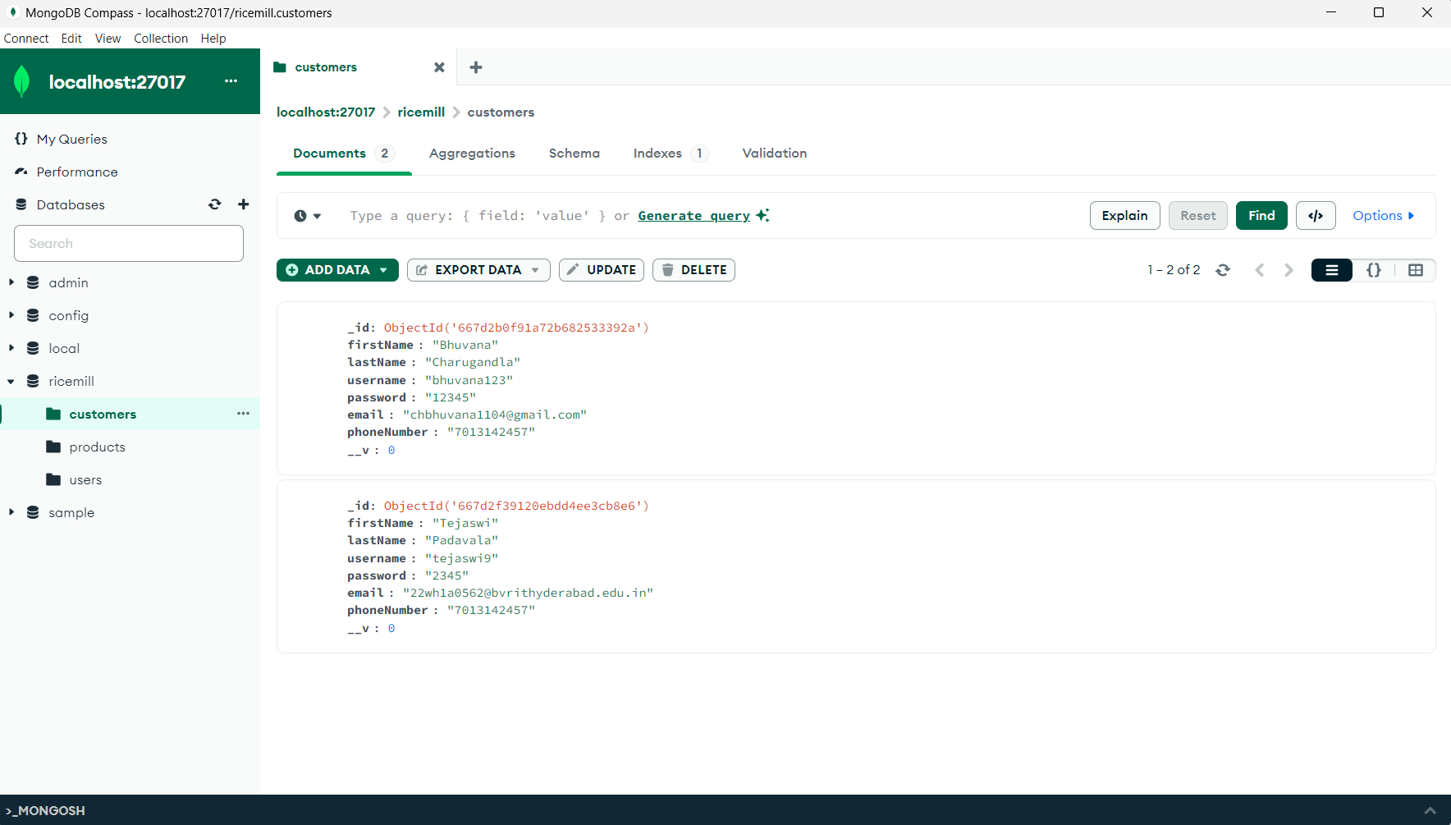

Figure-3: Registered users login credentials

Collection **‘products’:**

const productSchema = new mongoose.Schema({

    productname: String,

    price: Integer,

    discount: Integer,

stock: Integer

}, { collection: 'products' });

Figure-4: products collection schema

6

* 1. **Code**

<https://github.com/AkshayaSiripuram/Rice-Mill-Website>

**4.3 Output Snippets**



Figure-5: Home page

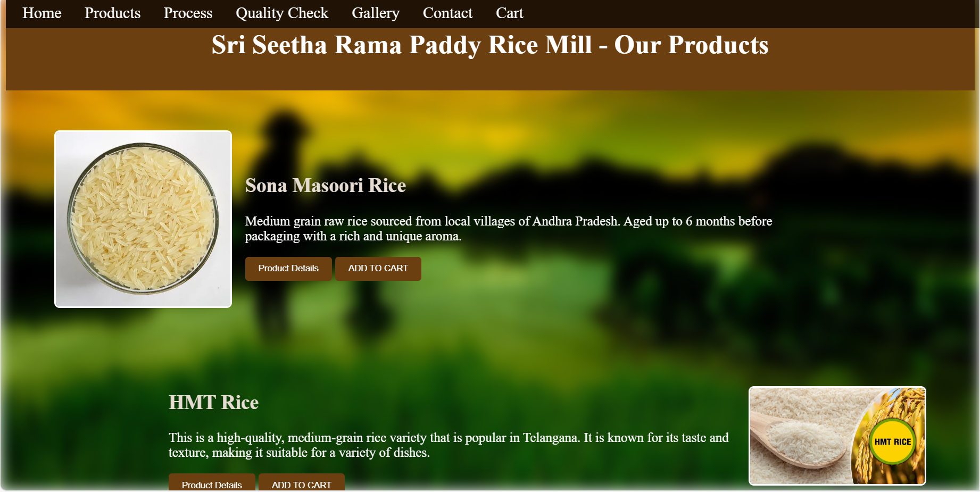

Figure-6: Products page

7

### **CONCLUSION AND FUTURE SCOPE**

#### In conclusion, the development of our rice mill website project represents a significant stride towards modernizing and optimizing operations within the rice milling industry. By leveraging full-stack technologies and innovative solutions, we have successfully designed and implemented a robust digital platform tailored to meet the complex needs of rice mill operators, suppliers, and stakeholders.

#### **Future Scope:**

The rice mill website project, built on robust full-stack technologies, has laid a solid foundation for future enhancements and expansions aimed at further revolutionizing operations within the rice milling industry. Key areas for future development and improvement include:

* **Advanced Analytics and Business Intelligence**: Enhance the platform with advanced analytics capabilities powered by machine learning and artificial intelligence algorithms. Implement predictive analytics to forecast production trends.
* **Blockchain for Traceability and Transparency**: Explore the implementation of blockchain technology to enhance traceability and transparency across the rice supply chain. Utilize blockchain's immutable ledger to track the journey of rice from farm to table, ensuring authenticity, reducing fraud, and enhancing consumer trust.
* **Enhanced User Experience (UX) and Interface (UI) Design**: Continuously improve UX/UI design to optimize user interactions and enhance usability across different devices and platforms. Incorporate responsive design principles, intuitive navigation, and personalized dashboards tailored to different user roles.
* **Scalability and Performance Optimization**: Architect the platform for scalability to accommodate growing data volumes, user base expansion, and increasing transactional demands. Utilize cloud-native technologies and microservices architecture to enhance scalability, resilience, and performance.
* **Continuous Integration and DevOps Practices**: Adopt continuous integration and DevOps practices to streamline development workflows, accelerate feature deployment, and ensure software quality. Implement automated testing, deployment pipelines, and monitoring tools to achieve faster time-to-market for new features and updates while maintaining stability and reliability.

By focusing on these future developments, the rice mill website can continue to evolve as a comprehensive digital platform that not only facilitates operational efficiency but also enhances collaboration, financial management, and customer satisfaction within the rice milling industry. These advancements will position our platform as a pivotal tool for modern rice mill operations, driving growth and sustainability in the competitive market landscape.

Top of Form

Bottom of Form

8

**6. REFERENCES**

[1] The article presents the development of a web-based information system for rice milling locations in Malind District, aimed at improving access and efficiency for farmers. This system enhances national food security by facilitating better rice milling operations

<https://www.e3sconferences.org/articles/e3sconf/abs/2021/104/e3sconf_icstunkhair2021_04027/e3sconf_icstunkhair2021_04027.html>

[2] **Maharajha Rice Mills Pvt. Ltd.** site offers detailed information about their various rice products, including Kolam Raw Rice, Mangalam Jeera Rice, and Tibar Basmati Rice. They emphasize their use of organic fertilizers and high standards of hygiene and quality​.

<https://www.maharajarice.com/>

[3] The book "Web Technologies and Applications" provides an in-depth exploration of full-stack development, covering essential technologies and methodologies for creating comprehensive web applications. It includes practical examples and case studies, such as building a rice mill website, demonstrating the application of these technologies in real-world scenarios.

<https://www.studocu.com/in/document/anna-university/be/ricemill-management-system/24210207 />

[4] We have also taken reference from Srilalitha Enterprises.

<https://srilalithaenterprises.com/>

9